
SRM Institute of Science and Technology
SET A
College of Engineering and Technology
School of Computing
DEPARTMENT OF NETWORKING AND COMMUNICATIONS
SRM Nagar, Kattankulathur – 603203, Chengalpattu District, Tamilnadu
Academic Year: 2022-2023
Test: CLAT-3 Date:
Course Code & Title: 18CSE308T: AWS Solution Architect Duration: 2 hrs
Year & Sem: III & V Max. Marks: 50 Marks

Part - A
(6 x 5 marks = 30 Marks) Instructions: Answer any six
Q. No | Question | Marks | BL
1 | Explain in brief about AWS Elastic Beanstalk | 5 | 2
2 | How does AWS Fargate work with Amazon ECS and Amazon EKS? | 5 | 3
3 | Differentiate AWS Fargate and AWS Lambda | 5 | 1
4 | Describe in brief about AWS RAM Managed permission. How can I monitor changes to resource shares? | 5 | 2
5 | What kinds of things can I do with CloudWatch Logs? | 5 | 3
6 | Which central governance and management capabilities do AWS Organizations enable? | 5 | 2
7 | Does Snowball Edge support EC2 instances? | 5 | 3
8 | How does AWS Secrets Manager implement database credential rotation without impacting applications? | 5 | 3
Part – B
(2 x 10 = 20 Marks)
9 | - Explain in detail the following factors on AWS Shield  - IPV6 on AWS Shield  - Types of attacks protect the users from  - Responding to the attacks  (or)  - Discuss in detail the following on AWS CloudTrail  - Benefits of CloudTrail  - Processing and storing of Log files  - Trails and security | 10  10 | 3  3
10 | - Elaborate in detail about the following  - Amazon SNS  - Amazon SQS  (or)  - Elaborate in detail about AWS DirectConnect  - Sitelink  - Service Interoperability  - Availability | 10  10 | 4  4

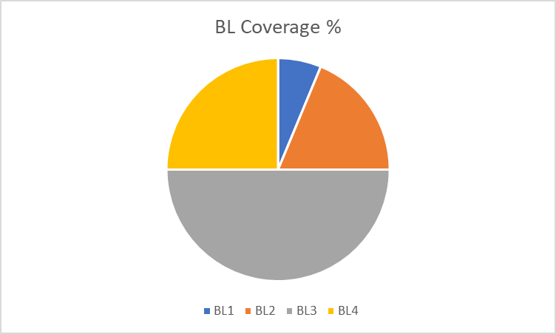

Approved by the Question Paper Scrutiny Team

